- Write in a standard form
  - $0.001 23$ b. $320 000$

- Write as a number
  - $3.24×{10}^{3}$ b. $8.2×{10}^{-4}$
- Give your answers in standard form
$a. \left(5×{10}^{-500}\right)×\left(7×{10}^{-400}\right)$ b. $\left(3.2×{10}^{-550}\right)÷\left(8×{10}^{-150}\right)$
- Give your answers in standard form
$a. \left(4×{10}^{301}\right)+\left(2.1×{10}^{300}\right)$ b. $\left(7×{10}^{-700}\right)-\left(2×{10}^{-702}\right)$
- Solve the following inequality and show the answers on a number line.
$4+2\left(3-5x\right)<30$
- Solve the following equations
- $\frac{x^{2}-1}{3}=5$ b. $3\sqrt{x+1}=24$
- Add the following algebraic fractions
  - $\frac{3x-1}{5}-\frac{x-2y}{25}+\frac{y+1}{10}$ b. $\frac{2}{3a}-\frac{5}{2b}+\frac{3}{ab}$
- Simplify the following algebraic fractions
  - $\frac{7x^{2}y}{15x^{3}}×\frac{(3x{y)}^{2}}{35xy}$ b. $\frac{6x^{2}}{14y^{2}}÷\frac{21x^{3}}{4x^{2}y}$
- Simplify the following algebraic fractions
  - $\frac{3x^{2}+6yx}{12xy}$ b. $\frac{2x^{2}y+10xy}{14xy+70y}$
- Find the equation of the line on the diagram below
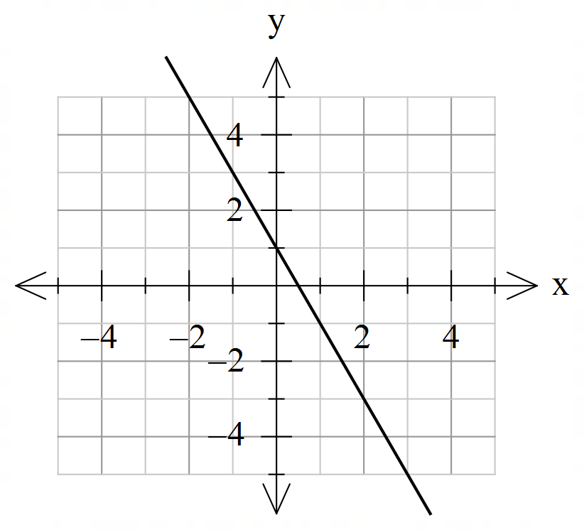
- Find the gradient of line passing through the points $(-3, 8)$ and $\left(5, -8\right).$
- Find the gradient and $y-$intercept of the line $y=2-5x$.
- Find equation of line parallel to line $y=8x-1 ,$ and passing through point (2,-11).
- a. Find the $x-$ and $y-$intercepts of line $5x-3y=45$.
b. Hence sketch the line.
- a. Draw lines $y=2x-1$ and $y=-x+4$ on the same set of axes: 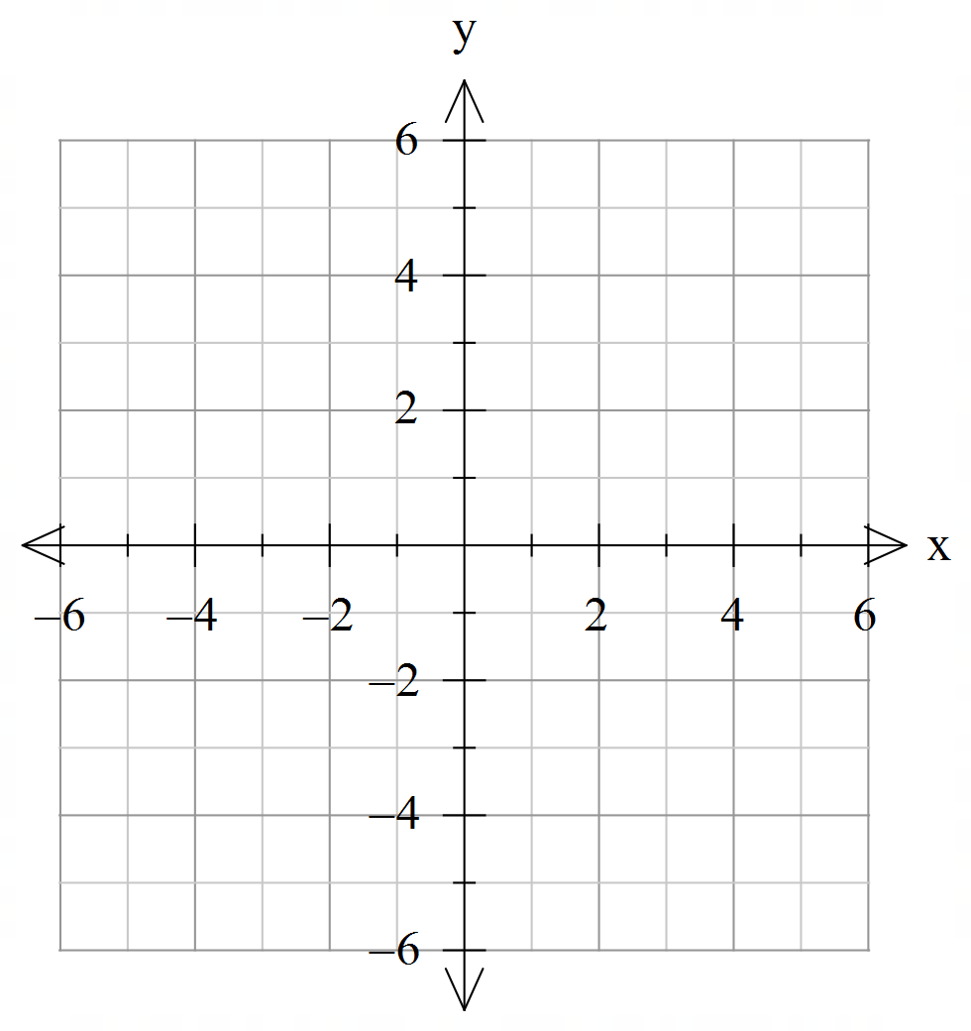
- Hence solve simultaneous equations graphically, using your graph.
$$y=-x+4$$
$$y=2x-1$$
- Find the missing side length in the diagram.
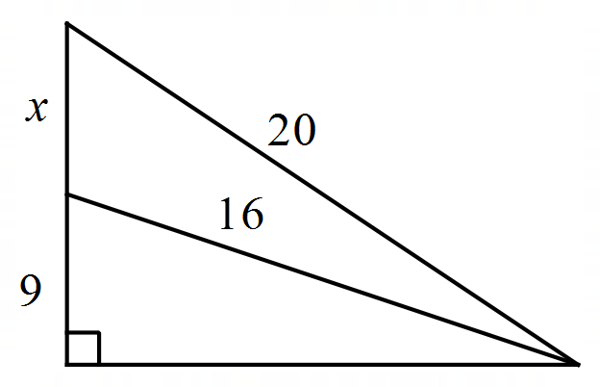

- Find the angle $x$, clearly state the reasoning.
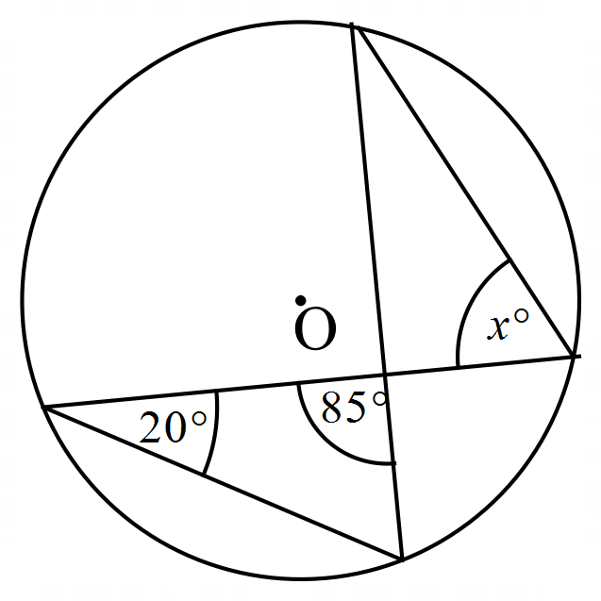
- Solve the following equations
  - $\frac{3x+2}{2}-\frac{x-1}{4}=\frac{x+1}{10}$ b. $\frac{x}{x+1}-\frac{1}{2}=\frac{1}{5}$

- Solve the following simultaneous equations by substitution:

$$3x+5y=1$$
$$y=x-3$$

